**Build RESTful with Spring Boot**

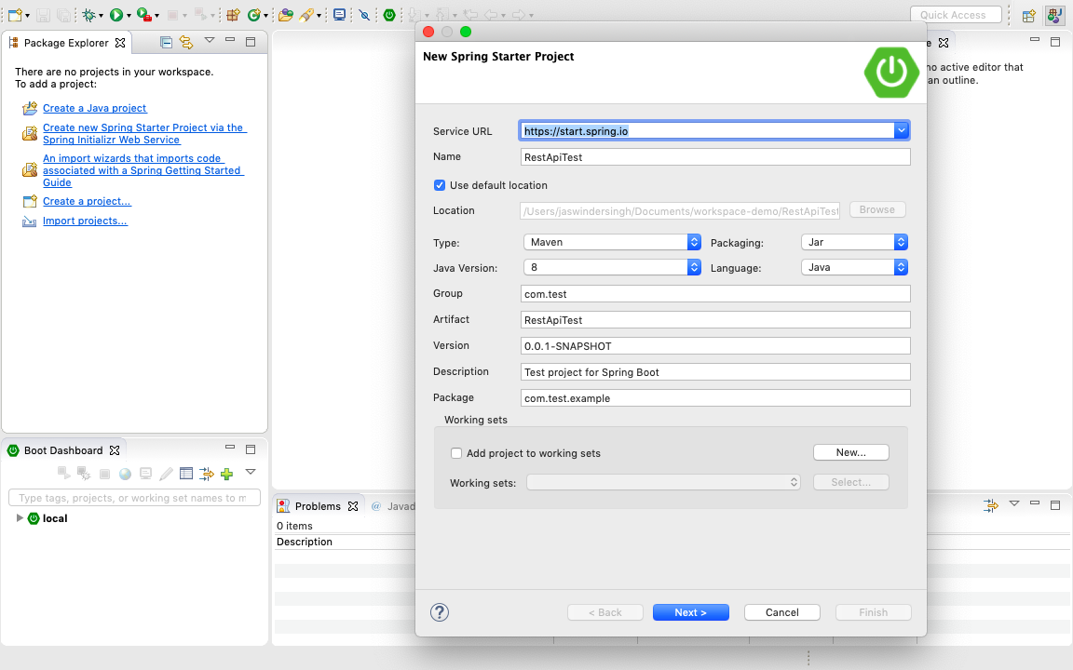

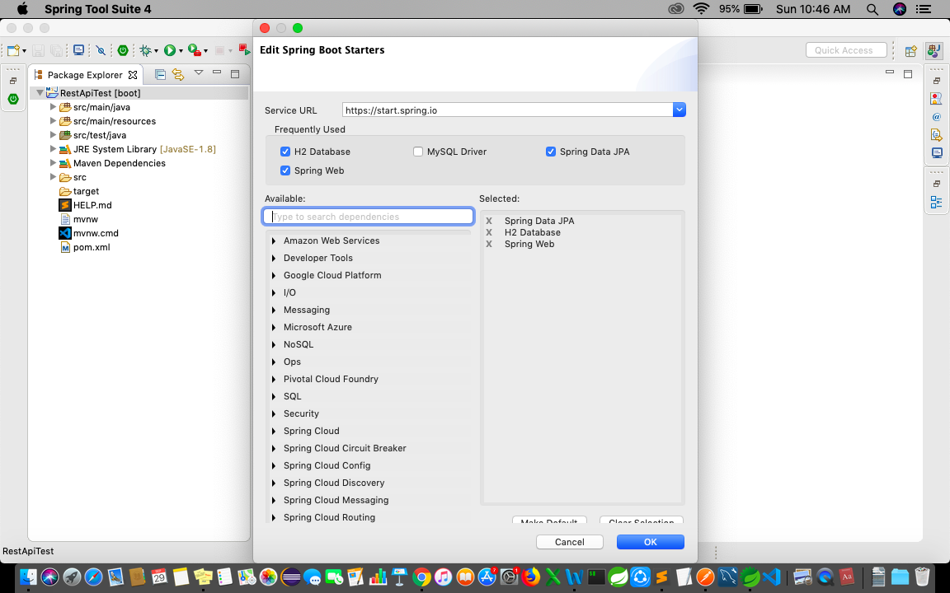

package com.test.example;

import org.springframework.boot.SpringApplication;

import org.springframework.boot.autoconfigure.SpringBootApplication;

@SpringBootApplication

public class RestApiTestApplication {

public static void main(String[] args) {

SpringApplication.run(RestApiTestApplication.class, args);

}

}

package com.test.example;

import javax.persistence.Column;

import javax.persistence.Entity;

import javax.persistence.GeneratedValue;

import javax.persistence.GenerationType;

import javax.persistence.Id;

@Entity

public class ProductEntity {

@Id

@GeneratedValue(strategy = GenerationType.AUTO)

@Column(name = "id", updatable = false, nullable = false)

private int id;

@Column

private String name;

@Column

private String description;

public ProductEntity() {

super();

}

public ProductEntity(int id, String name, String description) {

super();

this.id = id;

this.name = name;

this.description = description;

}

public int getId() {

return id;

}

public void setId(int id) {

this.id = id;

}

public String getName() {

return name;

}

public void setName(String name) {

this.name = name;

}

public String getDescription() {

return description;

}

public void setDescription(String description) {

this.description = description;

}

}

package com.test.example;

import org.springframework.data.jpa.repository.JpaRepository;

public interface ProductRepository extends JpaRepository<ProductEntity, Integer>{

}

package com.test.example;

import java.util.List;

import org.springframework.beans.factory.annotation.Autowired;

import org.springframework.stereotype.Service;

@Service

public class ProductService {

@Autowired

ProductRepository productRepository;

public List<ProductEntity> getAllProduct(){

return productRepository.findAll();

}

public ProductEntity getProduct(int id){

return productRepository.findById(id).get();

}

public void addProduct(ProductEntity pe){

productRepository.save(pe);

}

public void updateProduct(int id, ProductEntity pe){

if(productRepository.findById(id).isPresent()) {

ProductEntity oldProductEntity=productRepository.findById(id).get();

oldProductEntity.setName(pe.getName());

oldProductEntity.setDescription(pe.getDescription());

productRepository.save(oldProductEntity);

}

}

public void deleteProduct(int id){

productRepository.deleteById(id);

}

}

package com.test.example;

import java.util.List;

import org.springframework.beans.factory.annotation.Autowired;

import org.springframework.web.bind.annotation.PathVariable;

import org.springframework.web.bind.annotation.RequestBody;

import org.springframework.web.bind.annotation.RequestMapping;

import org.springframework.web.bind.annotation.RequestMethod;

import org.springframework.web.bind.annotation.RestController;

@RestController

@RequestMapping(path = "/webapi")

public class ProductController {

@Autowired

ProductService productService;

@RequestMapping("/allproduct")

public List<ProductEntity> getAllProduct(){

return productService.getAllProduct();

}

@RequestMapping("/product/{id}")

public ProductEntity getProduct(@PathVariable int id){

return productService.getProduct(id);

}

@RequestMapping(method=RequestMethod.POST, value="/product")

public void addProduct(@RequestBody ProductEntity pe ) {

productService.addProduct(pe);

}

@RequestMapping(method=RequestMethod.PUT, value="/product/{id}")

public void updateProduct(@PathVariable int id, @RequestBody ProductEntity pe ) {

productService.updateProduct(id, pe);

}

@RequestMapping(method=RequestMethod.DELETE, value="/product/{id}")

public void deleteProduct(@PathVariable int id) {

productService.deleteProduct(id);

}

}

